Task No & Title: Unit 10 | Unit Descriptor Unit Descriptor This unit covers the competencies required to start up a personal computer or business computer terminal, correctly navigate the desktop environment and use a range of basic functions.
Title: | BSBCMN107A Operate a Personal Computer
Suitable for Classes: | Certificate II Business
Area: | Technology & Enterprise
Teacher: | Mr Peter Faulks
Timeline | 1 Lesson
Date Due: | Today

Task Brief:

Files Required

Items highlighted in yellow are tasks for you to complete
Items in Purple are help tips

Unit | Number | Title | Study Time
1 | BSBCMN201A | Work effectively in a business environment | 20
2 | BSBCMN202A | Organize and complete daily work activities | 15
3 | BSBCMN203A | Communicate in the workplace | 30
4 | BSBCMN204A | Work effectively with others | 20
5 | BSBCMN205A | Use business technology | 30
6 | BSBCMN211A | Participate in workplace safety procedures | 15
7 | BSBCMN213A | Produce simple word processed documents | 40
8 | BSBCMN214A | Create and use simple spreadsheets | 20
9 | BSBCMN108A | Develop keyboard skills | 40
10 | BSBCMN107A | Operate a Personal Computer | 20
11 | ICAITU013C | Integrate Commercial computer packages | 30
12 | ICAITU012C | Design Organizational Documents using computer | 50
 |  | TOTAL

Start the computer

Turn on your computer
1. Start the computer
1.1 Check peripheral device connections for correct position
1.2 Switch on power at both the power point and computer

1. Windows

Start the computer using the power button

Enter your username and password then take a screen shot of your computer
(Windows PrtScr) Button or Macj Shift + Command + 4 then draw a box over image to select.

Windows
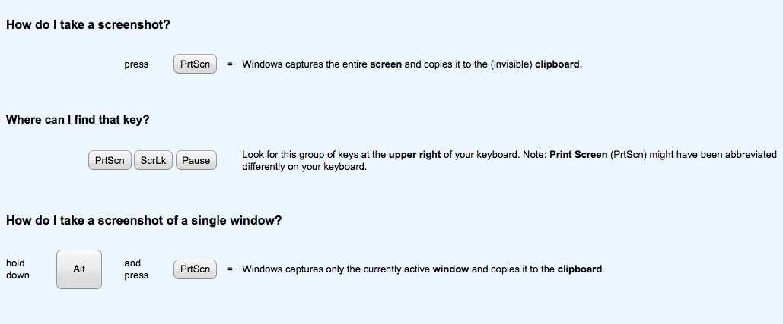

Mac
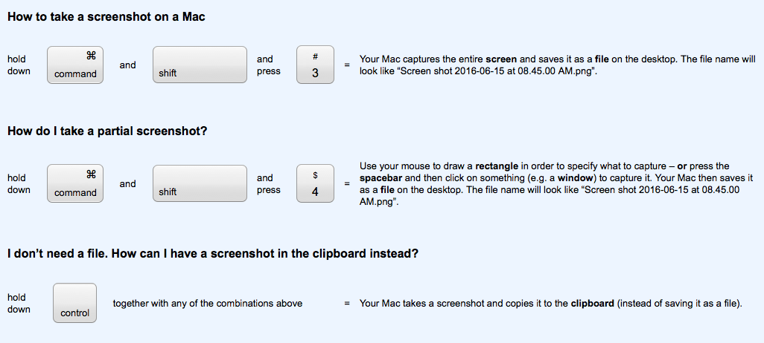

If you do not know how to use a mouse take this little tour

http://www.mouseprogram.com/practice.html

Paste your screen shot here

MY SCREEN SHOT

Basic computer functions
All computers, from the smallest hand held computer to the largest supercomputer, perform the same basic functions with digital information. Those functions are:
- Input—typing characters at a keyboard, moving the mouse around the screen or speaking to a computer
First Find your USB Thumb Drive / Flash Drive and create a folder
title this 01_C2IT_SurnameInitial (Surname = your surname and your Initial)
Inside this folder create another folder titled Unit 1
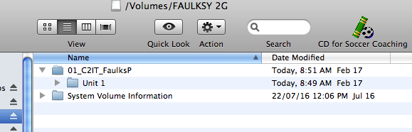

Open a Microsoft word document and type
Type: Certificate 2 Business
Type: Operating a Computer Cover Page
Type: Your name
- Output—displaying characters or pictures on the screen, printing a research paper, or sending an e-mail message
Save this word document to the folder that you have just created
- Process—calculating the square root of a number, sorting a list of names, or producing a three-dimensional image
Go to Desktop and use the Search or Find function
- Store—saving your research paper or resume, keeping track of your credit card purchases, or archiving digital pictures of your relatives
- Retrieve—recalling a list of addresses or business contacts
Find the folder FaulksP (this will be your surname)
Computers perform these five fundamental functions in different ways and at different speeds, but they all use digital data to perform the tasks.

What are the five fundamental functions
1

2

3

4

5

Save this document to the Unit 1 Folder
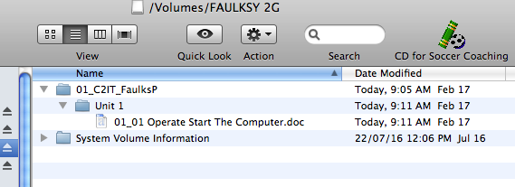

Open the cover page that you have created

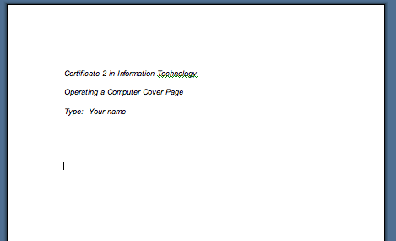

Improve the look and feel of the page by adding word art, different fonts and size and center all text, include a picture of you or a nice image that relates to this task

Now create all the Unit folders and save them to your USD Drive
Then copy the folder to your student drive or workspace.
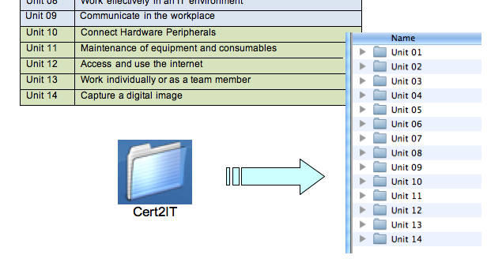
- Directories/folders are renamed (change the name of one of your folders = screen shot then change it back)

Task Customising Desktop Practical Activity

Customise the desktop of your PC using a variety of themes. Print Screen Dump of each to this word File (2 will do) and save as this document to Unit 01 later you will make a print copy for your portfolio (Unit 01).

3. Navigate and manipulate desktop environment
3.1 Create and customise desktop icons
3.2 Select, open and close desktop icons to access application programs
3.3 Manipulate application windows and return desktop to original condition

Show the following screen dumps: If on a Mac perform Mac Screen shots.

Replace the following images with your own

- Desktop icons are selected, opened and closed 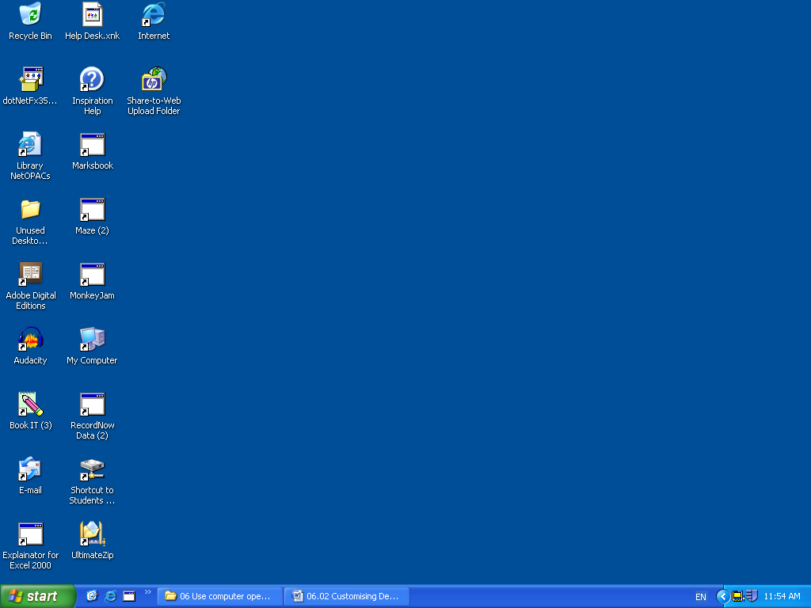
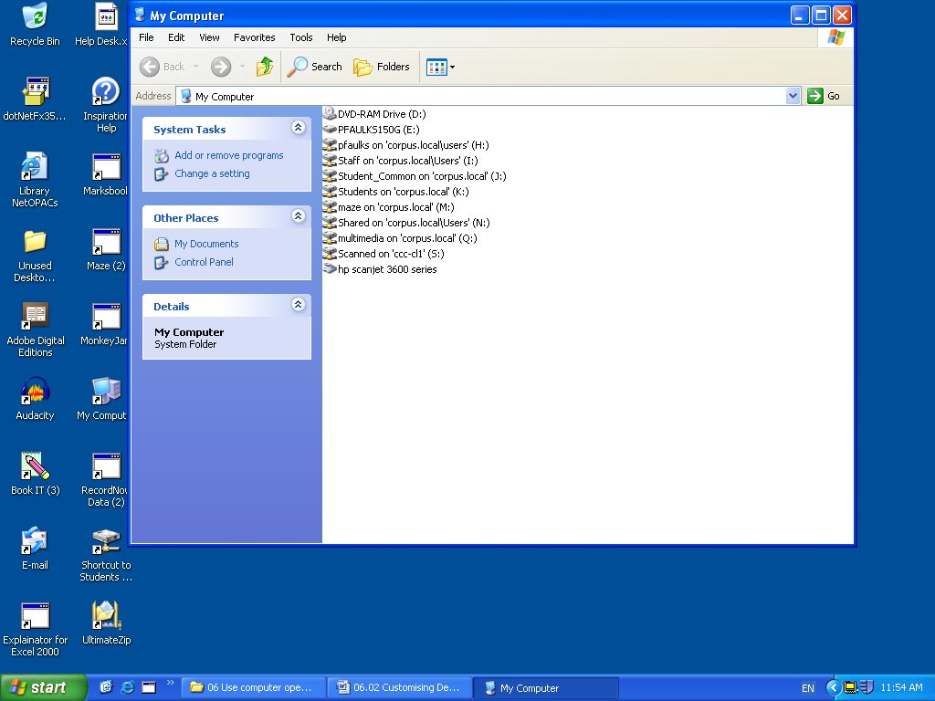
- Desktop windows are opened, resized and closed
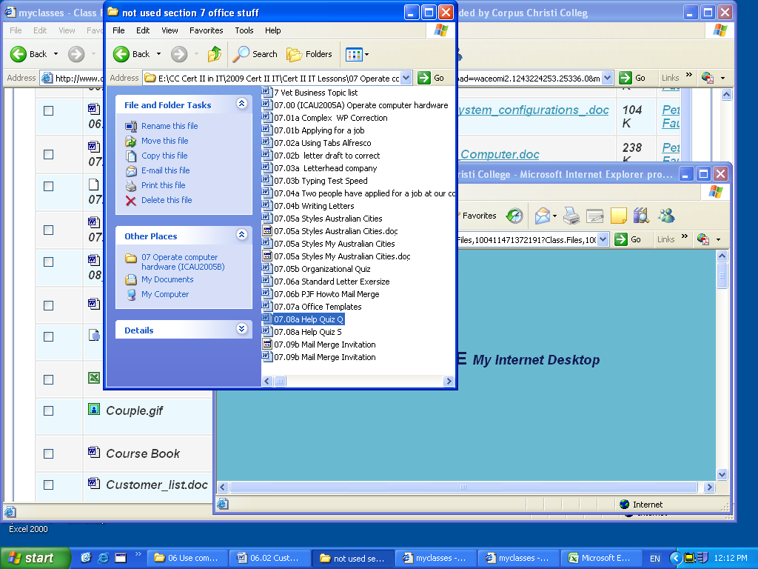
- Shortcuts (Aliases) are created from the desktop
- Create basic directory and folder structures
- Listing of Directories/folders with subdirectories/subfolders
(These are your Folder Files) Replace this image with yours
4. Organise basic directory/folder structure and files
4.1 Create and name directories and subdirectories
4.2 Identify attributes of directories
4.3 Move subdirectories between directories
4.4 Rename directories as required
4.5 Access directories and subdirectories via different paths

What makes up a Computer?
Two separate things make up a computer: hardware and software. They go hand in hand. You cannot have one without the other.
Directories/folders are renamed (change the name of one of your folders = screen shot then change it back)
5. Organise files for user and/or organisation requirements
5.1 Use system browser to search drives for specific files
5.2 Access the most commonly used types of files in the directories
5.3 Select, open and rename groups of files as required
5.4 Move files between directories
5.5 Copy files to disk
5.6 Restore deleted files as necessary
5.7 Erase and format disks as necessary

- Software tools are used to locate files e.g. search function Use the Find function on the computer (yes another screen shot please)
- Print information – show the printer queue Send a file to the printer = this you will put in your Portfolio under Unit 01
(yes another screen shot please)

Save the work

Student Name: | Date submitted:
I declare this evidence to have been produced by me the undersigned.

Candidate’s signature:
Title of Portfolio evidence presented Enter title here
BSBCMN107A Operate a Personal Computer Section 10:???
□ Outcomes from learning programs (including self-learning and online learning)
□ Assessment feedback (from a trainer or assessor)
□ Observation checklists (from a workplace supervisor or assessor)
□ Written statements or references (including workplace supervisors, community leaders)
□ Job descriptions
□ Work journal
□ Work samples
□ Finished products
□ Product descriptions or specifications (supporting the product samples included)
□ Statutory declarations
□ List others (or delete any from above not provided)
- All work submitted to be word processed and spell checked.
- There must be at least two samples of evidence for each
Element within the Unit of Competency. This is sample 1 / 2
- All work submitted must be of a high quality and meet the
requirements of the Unit of Competency.
Other evidence (List each piece):
Assessor to complete
Evidence is Valid Sufficient Authentic Current
□ □ □ □

Assessor signature: _________________________________Date: _____________
Peter Faulks, BA Soc Sci, Grad Dip Ed, Cert IV AWT
Certificate II in Business assessor/teacher
Assessor to complete

Student is declared Competent Not Yet Competent
□ □

Keep a copy of this report with your file for evidence

